**Template and Instructions for ECLC 2023 Abstract Submission (18pt)**

Maria Penelope De Santo1*, Riccardo C. Barberi1, and Roberto Bartolino2

1Physics Department, University of Calabria, Rende 87036, CS, Italy

2 CNR-Nanotec, c/o University of Calabria, Rende 87036, CS, Italy

This is a template for your preparation of abstracts to be submitted to the 16th European Liquid Crystal Conference to be held in Rende, Italy, July 10th-14th 2023.

The character font should be “Times New Roman” in the whole document. Please use the main text-lettering-size 12pt and margins size as given in this template. The headline on top should be 18pt and bold, followed by the authors of the contribution (12pt) and their affiliations (11pt). Affiliations should be numbered in the order of the authors. The presenting author should be underlined. Corresponding author should be identified with a raised asterisk.

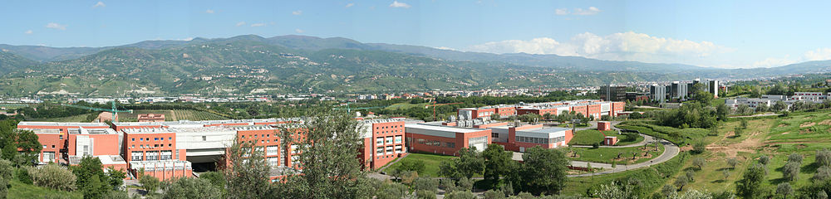

Figure 1. University of Calabria: venue of ECLC 2023

Illustrations should be numbered according to their sequence in the text. Each illustration should be accompanied by a caption. References should be cited in the text by square brackets, e.g. [1].

The abstract should be max of 2 pdf pages, A4 in length (including figures, tables, references) and should be submitted in MS-Word format with the file size not exceeding 3MB before March 31st 2023.

References: (10pt)

[1] M. P. De Santo et al., *Rend. Fis. Acc. Lincei* **26**:S2, 255–259 (2015)

[2] G. Pucci et al., *Liquid Crystals* **46**:4, 649-654 (2019).

* Author for Correspondence: maria.desanto@fis.unical.it